Forward Diffusion Noise Process

Noise Added Progressively to 5 Images

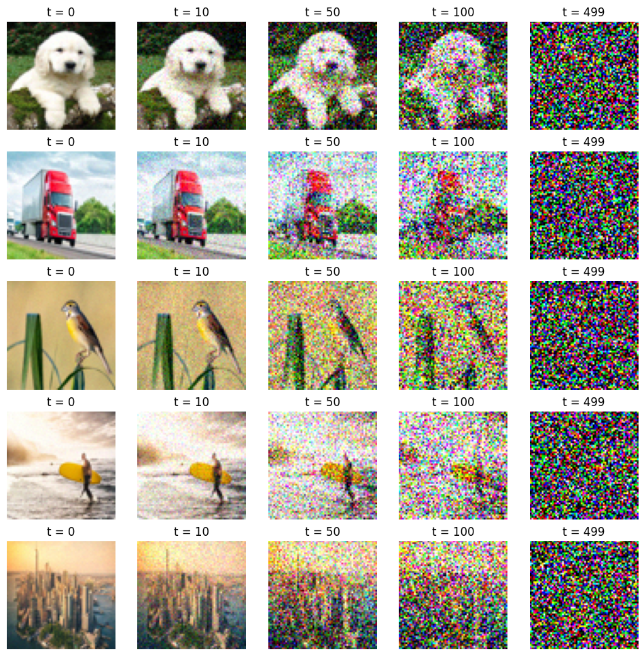

MSE Curve Over Time

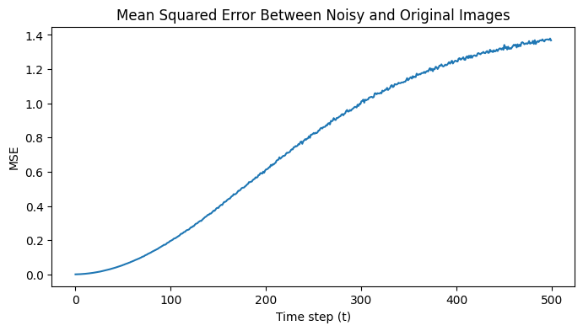

The MSE curve rises sigmoid-like because the noise scheduler adds minimal noise at earlier steps, and it speeds up quickly in the middle steps due to the increasing variance schedule. Towards the end of the noise being added, the MSE starts to plateau because the image becomes nearly all noise, and additional noise has little impact.

